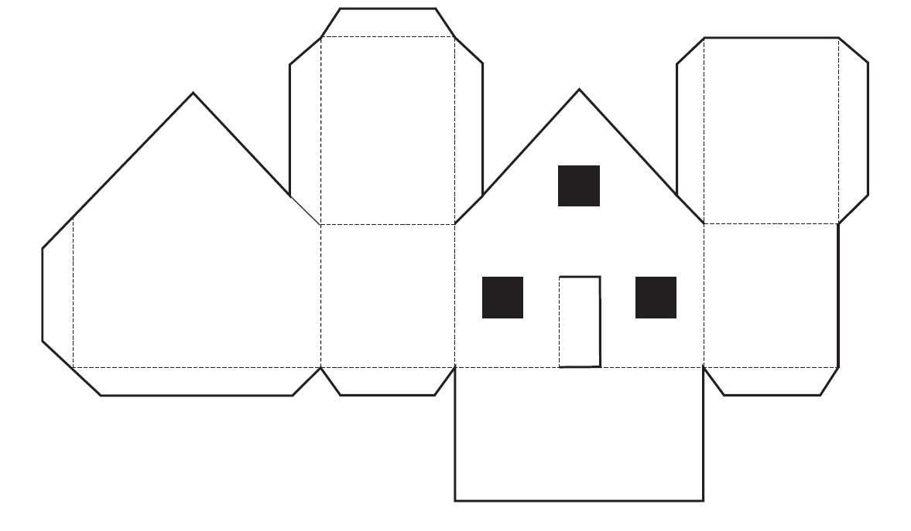

Can you build a log house? First, colour the house to make it look like a log home that an early settler would live in. Once it’s coloured in, follow the instructions below for construction.

**Instructions:**

1. Cut along solid lines

2. Fold along dashed lines

3. Cut out black sections